# PROJECT REPORT

On

BANK MANAGEMENT SYSTEM

Submitted

In the partial fulfillment of the requirement for the degree of

**BACHELOR OF COMPUTER APPLICATIONS**

**(Session 2018-2021)**

# Under the Supervision of: Submitted By:

Er .MD Ashif Raja Shalini Malik

Assistant Professor BCA 6thSemester

Dept. of Computer Sc. & Applications Roll No: 181032220013

**DEPARTMENT OF COMPUTER SCIENCE & APPLICATIONS**

**OM INSTITUTE OF TECHNOLOGY&MANAGEMENT**

**Affiliated to**

**GURU JAMBHESHWAR UNIVERSITY OF SCIENCE AND TECHNOLOGY, HISAR**

**PROJECT REPORT**

**On**

**BANK MANAGEMENT SYSTEM**

Submitted

In the partial fulfillment of the requirement for the degree of

**BACHELOR OF COMPUTER APPLICATIONS**

**(Session: 2018-2021**)



**Under the Supervision of: Submitted By:**

Er. MD Ashif Raja Shalini Malik

Assistant Professor

BCA 6thSemester

Dept. of Computer Sc. & Applications Roll No: 181032220013

**DEPARTMENT OF COMPUTER SCIENCE & APPLICATIONS**

**OM INSTITUTE OF TECHNOLOGY AND MANAGEMENT**

**Affiliated to**

**GURU JAMBHESHWAR UNIVERSITY OF SCIENCE AND TECHNOLOGY,**

**HISAR**

**DECLARATION**

I hereby declared that the minor project work titled as **“BANK MANAGEMENT SYSTEM”** Submitted for the BCA final Year Course is my original work carried out by me under the supervision of **Er. MD Ashif Raja** for the partial fulfillment of the award of the degree of the Bachelor of Computer Applications. The content written in this project has not submitted anywhere else for the award of any other degree/diploma for the BCA Degree.

**SHALINI MALIK**

This is to certify that the above statement make by the candidate is correct to best of our information.

**Er. MD Ashif Raja**

**PROJECT GUIDE**

**(ASSISTANT PROFESSOR)**

**PLAGIARISM CERTIFICATE**

It is certified that Mr. /Miss_______ s/o/d/o Sh.___________ Roll No______________ has carried out his/her research work on the topic

The complete thesis/dissertation/projects etc. has been checked by the plagiarism checker X. I have received the report of the plagiarism software index is ______ i.e. above/ below the accepted norms of the University. The thesis can be considered for standardization

**Supervisor Chairperson of the Department**

# Plagiarism Checker X Originality Report

|  |  |
| --- | --- |
| [http://plagiarismcheckerx.com/images/PlagiarismCheckerX-Icon.png](http://plagiarismcheckerx.com/) | Plagiarism Quantity: 4% Duplicate |

|  |  |
| --- | --- |
| Date | Friday, August 06, 2021 |
| Words | 211 Plagiarized Words / Total 4842 Words |
| Sources | More than 41 Sources Identified. |
| Remarks | Low Plagiarism Detected - Your Document needs Optional Improvement. |

# CERTIFICATE

This is to certify that **SHALINI** **MALIK**, Roll No.**181032220013** has worked under my supervision to prepare his Project report entitled **“BANK MANAGEMENT SYSTEM”.**The written material in this report is original and was conducted at OITM, Hisar during this session. This work has never been offered in part or in full in this or any other university by awarding any other degree or diploma.

Er.MD Ashif Raja

Assistant Professor

Dept. of Computer Sc. & Applications

**CERTIFICATE**

This is to certify that **SHALINI MALIK** Roll No.**181032220013** a student of Bachelor of Computer Applications being run by Om Institute of Technology & Management, Hisar batch of 2018-2021 has completed the project **“BANK MANAGEMENT SYSTEM”.** Under the supervision of Er.MD Ashif Raja. I wish her all success in her life.

**Dr. R.S.Sodhi**

**Associate Professor & HOD**

**Date: Dept. of Comp. Sc. & Applications**

**Acknowledgement**

It is a proud privilege for me to express my deep sense of gratitude to all those who have helped me during my project work. My Special thanks go to ***OITM, Dr. R. S.Sodhi*** Associate Professor & HOD (CSA) Dept. of Computer Sc. & App. For retaining complete faith of my strength to build this project.

I would like to thanks & have a great regards for Er.MD Ashif Raja, my Project Guide for his constructive support, cooperation and valuable for giving me this opportunity to undertake the project work and complete the said project on time..

At last but not the least I want to thank my parents also who have been very supportive during the tenure while carrying out this project. At last, I want to say that it was a good experience to work on this project.

**SHALINI MALIK**

**INDEX**

|  |  |  |
| --- | --- | --- |
| **Sr. No.** | **Table of Contents** | **Page No.** |
| **1** | **ABSTRACT** | **1** |
| **2** | **INTRODUCTION** | **2** |
| **3** | **OBJECTIVE** | **3-4** |
| **4** | **MAIN PURPOSE** | **5** |
| **5** | **PERFORMACE PROVIDED BY C++** | **6-7** |
| **6** | **INTRODUCTION TO C++** | **8** |
| **7** | **SYSTEM ANALYSIS** | **9** |
| **8** | **ELEMENTS OF SYSTEM ANALYSIS** | **10-11** |
| **9** | **SYSTEM DEVELOPMENT LIFE CYCLE** | **12** |
| **10** | **PRELIMINARY INVESTIGATION** | **13** |
| **11** | **SOFTWARE REQUIREMENTS** | **14-15** |
| **12** | **PROGRAMMING IN C++ & OUTPUT** | **16-48** |
| **13** | **SCOPE OF PROJECT** | **49** |
| **14** | **CONCLUSION** | **50** |
| **15** | **BIBLIGRAPHY** | **51** |

**ABSTRACT**

A Bank Account Management System is a request to keep a personal account in the bank in this рrоjeсt. I have tried to demonstrate the effectiveness’ of the bank ассоunt system as well includes the basic funсtiоnаlity of the Bank Aссоunt Management System. Doing the project resolving customer financial requests in banking conditions for expansion the needs of the end user of the bank by providing a variety of ways to perform banking functions and to enable the user's wоrksрасe to have аdditiоnаl funсtiоnаlity not рrоvided under а standard banking рrоjeсt. The main purpose of this project is to create Bank Account software Management System. This project was developed to make processes easier too quickly, which does not happen with manual programs, which are overcome by this software. This project was developed using PHP, HTML language and MYSQL application for database connection. Building and managing needs is a challenge for IT, systems and product development projects or actually in any project where you have to manage contract relationship. The organization needs to be well defined and manage needs in order ensure that they meet customer requirements, while proving compliance and staying in schedule and within budget. The impact of a badly articulated need can bring for disobedience or caused injury or death. Description of requirements as well management is a business that can bring high, fast returns to investment.

The project analyzes the system requirements and comes up with the requirements clarification. It reads other related programs and comes with system specifications.

The plan is then designed according to specific details to meet the requirements. The рrоgrаm design is then implemented with MYSQL, РHР and HTML. The рrоgrаm is by designed as а соntent management and соllаbоrаtiоn system. Content management system works with data entry, verification and verification when system deals interact system communication with managers and users.

**INTRODUCTION**

The aim of this project is to develop a program to reduce complication in banking system. In the current system all banking transactions are done manually. The user must visit the bank at the Withdrawal or Deposit amount. In the current banking system it is difficult to find the account holder's account details. In this banking system we will use the whole banking process. In our banking system the user can check his or her online balance and can transfer money to another online account. In this Software you can keep a record of daily bank transactions. The ultimate goal of developing a banking system is to design an app, which can store bank data and provide a customer-based interface for 100% accuracy.

This banking management system also allows the user to add a new customer account, delete the account and the user can change existing user account details. You are using this application user and can search for any individual account in a few seconds. You use our banking system administrator and can check any translations in any account. Our system also provides a security check to reduce fraud. The system will check the user's presence in the database and provide a set of services in relation to the user's role.

**OBJECTIVE**

The key of this program is to provide a secure system. Our system is password protected and only allows authorized users to access various functions found in the system.

Our system will help the user to get any A / C desired by the user. It will reduce manual labor as most computer work is done. Since all manual labor will be done automatically. It will also increase the work speed and reduce the time spend completing any bank related work. It will also increase efficiency as few employees are able to manage multiple customers. This will reduce the workload and provide faster information.

The Project Banking system is designed to make the Bank system more flexible. By this mean banking management administration the account holder can handle all bank account activities such as deposit money, withdraw money, transfer money from one account to another account, pay online etc. statement etc. The administrator can check the bank account by logging in who can work with the A / C owners of the bank who can withdraw / deposit / check / DD on their accounts. This program also helps the bank user to create a new account easily. The project makes a concerted effort to -provide all of the items listed below to meet the needs of the bank.

In this project we have automated banking processes such as Account opening, Daily Transactions, Loan Penalties, Account Retention. In this system of banking management the use may also search the record of a particular Account Owner.

Using this application user can manage the following account type:

* Savings Account
* Current account
* Fixed Bond Account
* Frequent Deposit Account
* Credit Account

This software offers two types of accounts to customers, one called a savings account one as the current account. The savings account offers the combined interest and withdrawals institutions but there is no checkbook domain. The current account provides a place for checks however no interest .Current Aссоunt holders should keep а small bаlаnсe and if the bаlаnсe falls below this level, including service сhаrge. In this software there is а class ассоunt that stores the сustоmer name, ассоunt number and ассоunt type. From this, find the current account and saving account classes to make them more specific to them requirements.

Features:

---------

(a) Accept customer deposit and review balance.

(b) Indicate the balance.

(c) Pay and charge interest.

(d) Allow withdrawals and update the balance.

(e) Look at the low balance, place a fine, if necessary, and update the balance.

Limitation:

--------------

(a) You can manage only one customer service

(b) There is no database and file handling, so the data is temporary

**Main Purpose**

The customary method of storing user details in a bank was to enter the data again record them. Every time a user needs to make a transaction they have to go to the bank again perform the necessary actions, which may not always be possible. It can be a daunting task to beat users and bankers too. The project provides a real-life understanding of online banking system and services for various roles in real estate we offer variables via the Internet banking system. Online Banking System Project captures the functions performed by the various roles in the real life bank that provides development the techniques for keeping the required information are up-to-date, leading to efficient operation.

This project provides a real-life understanding of the Online Banking system and the functions performed with various roles in the sale of goods

**Performance Provided by the C ++ Project in the Resource Recruitment Program As follows:**

* Provides search services according to various features. As an employer, employer registration, postal service, interview
* College Management System also sells employee information online with student information, employee details and courses.
* It tracks all information Call Book, Search Job, Send Job etc.
* Manage Call Letter details
  + Displays details and details of Employer, Employer Registration
  + Increasing the efficiency of the Employer management, Call Letter
* It works by monitoring the details and transactions of Post Job.
* Manage Employer information
* Editing, Installing and Updating Records is enhanced leading to better management of Employee data resources
* Manage Post Job details
* Compilation of all Interview records.

**Limitation:**

Limit on C ++ Project on Recruitment Management System:

* Excel export is not made for Search Job, Post Job due to specific importance.
* Transactions are done in offline mode, which is why Employee’s online data, Call Capture and conversion are not possible.
* Offline Reports of Employer, Employer Registration, and Conversation cannot be made due to batch mode use.
* C ++ Project Installation and Verification Data in the Property Rental Program
* All categories such as Employer, Employer Registration, Interview are verified and do not take invalid values
* Each Employer form, Call Letter, Search Job cannot accept empty price fields
* Avoid data errors
* Controls the amount of input

**Introduction of C++**

Some languages are close to machine like assembly language and some are close to programmer but c++ serves the both aspect that why it is middle level language.

C++ is an OOPs based language developed by Bjrane Stroustrup at AT&T Bell laboratories at New Jersey, USA, in 1980’s

C++ is superset of C language which allows all C programs to run under C++ but under few conditions only they may not work on C++.

The object oriented features of C++ allow us to develop the larger programs under less time easily with the all included features and efficiency of C.

C was developed and extended more so that to make it more powerful so that it can do more powerful operations and programmer can develop with new features and power and later name as C++.

**System Analysis**

**What is System?**

System is well organized collection of interdependent bodies and modules which all works together to achieve a goal. It can be anything like accounting system for managing accounts and so on. In the same way the university management system is a system designed to manage the university related things like courses etc.

**Systems Study, Analysis and Approach:**

System study is simply defined as all the required study on system development operations expenses uses eligibility etc. however system approach is the method or the way how a system is to be developed and what approaches are to be used to develop the system identify and then solving the problems, and an analysis is analyzing the whole system thought the development, and provides the techniques and helps in the designing of a new system or an update on new system.

Elements of Systems Analysis

These are four basic elements in systems analysis. Brief about every element as follow:

a. **Outputs:** First of all, we must determine what the objectives or goals are, what do we intend to aim, what is the objective or goal of our activity; in other words, what is the main reason behind the system. Straitening goal is very important in system work. If we do not know whose we want to go, we will not know when we have reached this. We are wasting energy, efforts and time in the process. Once we know the target, we can try to achieve it in the best happening way. I have collect this information from many companies, which they desired in his Online Examination & Selection procedure. These become the outputs which the systems analyst keeps into mind.

b. **Inputs:** One time we know the outcome, we can easily understand what the inputs should be. Sometimes, it may happen that the required information may not available in using form. This may be because of lack of the better designing. sometimes,without the help of top management hard to get the data and information. If the data is important to the system, we should make all possible efforts to make it available. Sometimes, it might be too costly to get die-desired information. It needs improvement in such cases to ready a cost-effective analysis to induce the management of the necessity for acquiring the information. The essential elements of inputs are:

1. **Accuracy:**  If the data is not right the output will be garbage
2. **Timeliness:** data should be entered and provided at right time
3. **Proper format:** the format for data input must be well managed to be process.
4. **Economy:** The data must be produced at the least amount of cost.

5. **Files:** Files are mandatory to save the history and the data created inside the system and to be saved in a file for future use.

6. **Processes:** this is how we reach at the output by processing the input data and generating the output.

System Development Life Cycle

Whenever we need to develop and system it is must to work step by step in different phases so that it had a life cycle from start to the end, which can be said as system development lifecycle in which we start from designing to the deployment. The SDLC consist activities as follow:

* Preliminary investigation
* Determination of system requirements
* Designing of system
* Develop of software
* Testing of syste1m
* Implementation, evaluation and maintenance

Preliminary Investigation

Preliminary is the first part of the SDLC .It checks the first part of system is analysis. It clears the conduct for initial phase of the SDLC

1. Analysis request

2. Feasibility check

3. Approve system

Analysis request: requests from customers and users in the organizations are not exactly defined it becomes check the request of the analysis of system to find out problem.

Feasibility check: This is important part of investigation to check feasibility. Because it depends on any organization running

1. **Technical Feasibility**: if the old technology is many time uses in organization. The customers are bored. Organizations think to develop a new technology to upgrade your benefits for clients

2. **Economic Feasibility:** it is important because organization is financial situation is good then it will pay on salary to employees.

Economical organization is good for investing in respect of organization.

3. **Operational Feasibility**: if the system is ready then go for it operations and go for testing & implanted by to ready for every requirement permission.

System Requirements

**Hardware Requirements**

The following minimum configuration is required:

* Processor: Must be core duo about 1.6 GHZ
* Memory: Must be at least the 512 MB specified for the operating system you are using.
* Free space:
  + 1Gb
* This disk size includes the space needed to cache information locally so that you can modify the installation without the original source media.
* DVD drives (either locally or via a network).
* Screen resolution is 720p HD+
* Developer has additional hardware requirements the same as for Microsoft Visual Studio. See the Visual Studio documentation for details.

# 

# Software Requirements

The following software is required:

* On 32-bit Windows OS, one of:
  + Windows Vista OS
  + Windows Server 2008 OS
  + Windows Server 2003 R2 OS, Windows Server 2003 OS
  + Windows XP Professional SP2 OS or later
* On 64-bit Windows for X64, one of:
  + Windows Vista
  + Windows Server 2008
  + Windows XP Professional
  + Windows Server 2003

Programing

In



#include<iostream>

#include<conio.h>

#include<stdio.h>

#include<string.h>

#include<math.h>

#include"welcome.cpp"

class Transaction;

void main_menu(Transaction&);

char trans(Transaction&);

using namespace std;

class user // User Class

{

protected:

char name[25];

char Fname[25];

char Mname[25];

char Cname[25];

char Nname[25];

char email[25];

int age,i;

char mobi[12];

char AadharC[12];

char Pname[12];

public:

void usergetdata()

{

cout<<"\n\t\t\t\t\t Enter Full Name : ";

for(i=0;i<25;i++)

{

name[i]=0;

}

i=0;

fflush(stdin);

gets(name);

cout<<"\n\t\t\t\t\t Enter Email-ID : ";

for(i=0;i<25;i++)

{

email[i]=0;

}

i=0;

cin>>email;

cout<<"\n\t\t\t\t\t Enter Father-Name : ";

for(i=0;i<25;i++)

{

Fname[i]=0;

}

i=0;

cin>>Fname;

cout<<"\n\t\t\t\t\t Enter Mother-Name : ";

for(i=0;i<25;i++)

{

Mname[i]=0;

}

i=0;

cin>>Mname;

cout<<"\n\t\t\t\t\t Enter City-Name : ";

for(i=0;i<25;i++)

{

Cname[i]=0;

}

i=0;

cin>>Cname;

cout<<"\n\t\t\t\t\t Enter Age : ";

cin>>age;

cout<<"\n\t\t\t\t\t Enter Mobile No : ";

for(i=0;i<12;i++)

{

mobi[i]=0;

}

i=0;

cin>>mobi;

cout<<"\n\t\t\t\t\t Enter Aadhar card No : ";

for(i=0;i<12;i++)

{

AadharC[i]=0;

}

i=0;

cin>>AadharC;

cout<<"\n\t\t\t\t\t Enter Pancard no.";

for(i=0;i<10;i++)

{

Pname[i]=0;

}

i=0;

cin>>Pname;

cout<<"\n\t\t\t\t\t Enter Nomainee-Name : ";

for(i=0;i<25;i++)

{

Nname[i]=0;

}

i=0;

cin>>Nname;

}

void nam() // Name display

{

cout<<name;

}

};

class Account : public user //Account class ,Use class inherit

{

protected:

char accnt[16],type,password[18],yes;

int blnc,i;

public:

void accntgetdata()

{

usergetdata();

cout<<"\n\t\t\t\t\t Enter Account No : ";

for(i=0;i<16;i++)

{

accnt[i]=0;

}

i=0;

cin>>accnt;

retry: // label if Amount less

cout<<"\n\t\t\t\t\t Enter type of Account (C/S) : ";

cin>>type;

blnc=0;

if(type=='s' || type =='S')

{

five:

cout<<"\n\t\t\t\t\t Enter Initial Amount (>= Rs.500) : ";

cin>>blnc;

if(blnc<500){

cout<<"\n\t\t\t\t Please Enter greater than Rs.500"<<endl;

goto five;

}

}

else if(type=='C' || type =='c')

{

ten:

cout<<"\n\t\t\t\t\t Enter Initial Amount (>= Rs.1000) : ";

cin>>blnc;

if(blnc<1000){

cout<<"\n\t\t\t\t Please Enter greater than Rs.1000"<<endl;

goto ten;

}

}

else

{

cout<<"\n\t\t\t\t Try Again Press 'c' for Current Account , 's' for Saving Account"<<endl;

goto retry;

}

cout<<"\n\t\t\t\t\t Create Password : ";

for(i=0;i<18;i++)

{

password[i]=0;

}

i=0;

while((password[i]=getch())!='\r')

{

printf("*");

i++;

}

system("cls");

jio();

cout<<"\n\n\n\n\n\n\n\n\n\n\n\t\t\t\t\t\t\t\t Press 'Y' to Confirm 'N' to retry : ";

cin>>yes;

if(yes=='y' || yes=='Y')

{

cout<<"\n\n\n\t\t\t\t\t Account Successfully Created ";

getch();

}

else

{

system("cls");

jio();

cout<<endl<<endl<<endl<<endl;

accntgetdata();

}

}

};

class Transaction : public Account // class Transaction , Account Inherit

{

int amnt,p,t;

float r,ci;

public:

Transaction()

{

amnt=0;

}

void displ()

{

cout<<"\n\n\t\t Account Name is "<<name;

cout<<"\n\t\t\t Balance is "<<blnc;

getch();

}

void deposit() // Deposit

{

dep:

cout<<"\n\n\t\t\t\t\t\t\t Enter amount to Deposit : ";

cin>>amnt;

if(amnt>=100)

{

blnc=blnc+amnt;

}

else

{

cout<<"\n\n\n\t\t\t\t\t\t\t\t\t\tAmount Should be Greater than equal Rs.100 "<<endl<<endl<<endl;

goto dep;

}

cout<<"\n\n\n\n\t\t\t\t\t\t\t\t You have Deposited Successfully ";

cout<<"\n\n\n\n\n\n\t\t\t\t\t\t\t Current Balance is Rs."<<blnc;

getch();

}

void withdraw() // Withdraw

{

with:

cout<<"\n\n\t\t\t\t\t\t\t Enter amount to Withdraw : ";

cin>>amnt;

if(amnt>=100)

{

if(blnc-amnt<0)

{

cout<<"\n\n\n\n\t\t\t\t\t\t\t\t\t Insufficient Balance ";

getch();

return;

}

else

blnc=blnc-amnt;

}

else

{

cout<<"\n\n\n\t\t\t\t\t\t\t\t\t\tAmount Should be Greater than equal Rs.100 "<<endl<<endl<<endl;

goto with;

}

cout<<"\n\n\n\n\t\t\t\t\t\t\t\t You have Withdrawl Successfully ";

if(type=='c' || type=='C')

{

if(blnc<1000)

{

cout<<"\n\n\n\t\t\t\t\t\t Your have cross the limit of minimum balance charges may apply ";

blnc=blnc-100;

}

}

cout<<"\n\n\n\n\n\n\t\t\t\t\t\t\t Current Balance is Rs."<<blnc;

getch();

}

void blncenquiry() // Balance Enquiry

{

cout<<"\n\t\t\t\t\t\t\t Name : "<<name;

cout<<"\n\n\t\t\t\t\t\t\t Account No : "<<accnt;

if(type=='s' || type== 'S')

cout<<"\n\n\t\t\t\t\t\t\t Type of Account : Saving";

else

cout<<"\n\n\t\t\t\t\t\t\t Type of Account : Current";

cout<<"\n\n\n\n\n\t\t\t\t\t\t\t\t\t\t Your Available balance is Rs."<<blnc;

getch();

}

void checkbk()

{

if(type=='c' || type=='C')

{

system("cls");

jio();

cout<<"\n\n\n\n\n\n\n\n\n\n\n\n\n\n\t\t\t\t\t\t\t\t\t\t\t Cheque Book Facility Available";

getch();

}

else

{

system("cls");

jio();

cout<<"\n\n\n\n\n\n\n\n\n\n\n\n\n\t\t\t\t\t\t\t\t\t\t\t Cheque Book Facility Not Available";

getch();

}

}

void netbanking()

{

if(type=='c' || type=='C')

{

system("cls");

jio();

cout<<"\n\n\n\n\n\n\n\n\n\n\n\n\n\n\t\t\t\t\t\t\t\t\t\t\t Netbanking Facility Available";

getch();

}

else

{

system("cls");

jio();

cout<<"\n\n\n\n\n\n\n\n\n\n\n\n\n\t\t\t\t\t\t\t\t\t\t\t Netbanking Facility Not Available";

getch();

}

}

void atm()

{

if(type=='c' || type=='s')

{

system("cls");

jio();

cout<<"\n\n\n\n\n\n\n\n\n\n\n\n\n\n\t\t\t\t\t\t\t\t\t\t\t ATM Facility Available";

getch();

}

else

{

system("cls");

jio();

cout<<"\n\n\n\n\n\n\n\n\n\n\n\n\n\t\t\t\t\t\t\t\t\t\t\t ATM Facility Not Available";

getch();

}

}

void compound()

{

system("cls");

jio();

if(type=='s' || type=='S')

{

cout<<"\n\n\n\n\n\n\n\n\t\t\t\t\t\t\t Enter Principle Amount : ";

cin>>p;

cout<<"\n\n\t\t\t\t\t\t\t Enter the rate of interest : ";

cin>>r;

cout<<"\n\n\t\t\t\t\t\t\t Enter the time : ";

cin>>t;

ci=p*(pow((1+r/100),t));

cout<<"\n\n\n\t\t\t\t\t\t\t\t\t The Compound Interest is : "<<ci<<endl;

}

else

cout<<"\n\n\n\n\n\n\n\n\n\n\t\t\t\t\t\t\t Compound Interest Not Available in Current Account";

getch();

}

void info()

{

system("cls");

jio();

system("color d");

cout<<"\n\n\n\n\n\n\n";

cout<<"\n\n\t\t\t\t\t\t\t\t Name : "<<name;

cout<<"\n\n\t\t\t\t\t\t\t\t Account No : "<<accnt;

cout<<"\n\n\t\t\t\t\t\t\t\t Age : "<<age;

cout<<"\n\n\t\t\t\t\t\t\t\t Email-Id : "<<email;

cout<<"\n\n\t\t\t\t\t\t\t\t Mobile NO : "<<mobi;

if(type=='S' || type=='s')

cout<<"\n\n\t\t\t\t\t\t\t\t Type of Account : Saving";

else

cout<<"\n\n\t\t\t\t\t\t\t\t Type of Account : Current";

cout<<"\n\n\t\t\t\t\t\t\t\t Available Balance : Rs."<<blnc;

getch();

system("color 7");

}

friend char check(Transaction a1,char accnt2[],char password2[]);

};

char check(Transaction a1,char accnt2[],char password2[])

{

char sign;

if(strcmp(a1.accnt,accnt2)==0 && strcmp(a1.password,password2)==0)

{

system("cls");

jio();

cout<<endl<<endl<<endl<<endl;

cout<<"\n\n\n\n\n\n\n\n\n\n\n\n\n\n\n\t\t\t\t\t\t\t\t\t\t\t Welcome ";a1.nam();

sleep(2);

// system("cls");

//jio();

sign=trans(a1);

return sign;

}

else

{

cout<<"\n\n\n\n\n\n\n\t\t\t\t\t\t\t\t\t\t\t Invalid Account No OR Wrong Password ";

getch();

}

}

int main()

{

Transaction a1;

main_menu(a1);

getch();

return 0;

}

char trans(Transaction &a1)

{

char ch;

int i=0;

while(1)

{

system("cls");

jio();

cout<<"\n\n\n\n\n\n\t\t\t\t\t\t\t\t\t\t\t 1. Deposit Amount ";

cout<<"\n\n\t\t\t\t\t\t\t\t\t\t\t 2. Withdraw Amount ";

cout<<"\n\n\t\t\t\t\t\t\t\t\t\t\t 3. Balance Enquiry ";

cout<<"\n\n\t\t\t\t\t\t\t\t\t\t\t 4. Cheque Book Facility";

cout<<"\n\n\t\t\t\t\t\t\t\t\t\t\t 5. Calculate Compound Interest ";

cout<<"\n\n\t\t\t\t\t\t\t\t\t\t\t 6. Account Info";

cout<<"\n\n\t\t\t\t\t\t\t\t\t\t\t 7. Netbanking Facility";

cout<<"\n\n\t\t\t\t\t\t\t\t\t\t\t 8. ATM Facility";

cout<<"\n\n\n\n\t Exit(e) \t\t\t\t\t\t\t\t\t\t\t\t\t\t\t\t\t\t\t\t\t Sign Out(s)";

cout<<"\n\n\n\n\n\n\t\t\t\t\t\t\t Enter your choice : ";

cin>>ch;

switch(tolower(ch))

{

case'1':system("cls");

jio();

cout<<endl<<endl<<endl<<endl<<endl<<endl<<endl<<endl<<endl;

a1.deposit();

break;

case'2':system("cls");

jio();

cout<<endl<<endl<<endl<<endl<<endl<<endl<<endl<<endl<<endl;

a1.withdraw();

break;

case'3':system("cls");

jio();

cout<<endl<<endl<<endl<<endl<<endl<<endl<<endl<<endl<<endl<<endl<<endl;

a1.blncenquiry();

break;

case '4': a1.checkbk();

break;

case'5':a1.compound();

break;

case '6':a1.info();

break;

case '7':a1.netbanking();

break;

case '8':a1.atm();

break;

case 'e':system("cls");

jio();

system("color c");

cout<<"\n\n\n\n\n\n\n\n\n\n\n\n\t\t\t\t\t\t\t\t\t\t\t\t Thank You";

cout<<"\n\n\n\n\n\n\n\n\n\n\n\n\t\t\t\t\t\t\t\t\t\t Creted By : Rajkumar Rocktim Narayan Singha";

sleep(2);

exit(0);

case 's':cout<<"\n\n\n\n\n\n\n\n\n\n\t";

for(i=0;i<8;i++)

{

sleep(1);

cout<<"===== ===== ==== ==== ==== ";

}

return 's';

default: cout<<"\n\n\n\t\t\t Invalid Choice ";

}

}

getch();

}

void main_menu(Transaction &a1)

{

welcome();

char ch,sign;

int i=0;

while(1)

{

system("cls");

jio();

cout<<"\n\n\n\n\n\n\n\t\t\t\t\t\t\t MAIN MENU "<<endl<<endl;

cout<<"\t\t\t\t\t 1. Create Account"<<endl<<endl;

cout<<"\t\t\t\t\t 2. Sign in"<<endl<<endl;

cout<<"\t\t\t\t\t 3. Exit"<<endl<<endl;

cout<<"\n\n\t\t\t\t\t Enter your choice : ";

cin>>ch;

switch(ch)

{

case '1':system("cls");

jio();

cout<<endl<<endl<<endl<<endl;

a1.accntgetdata();

break;

case '2':system("cls");

jio();

char accnt2[16],password2[18];

cout<<"\n\n\n\n\n\n\n\n\t\t\t\t\t\t\t\t\t Enter Account No : ";

cin>>accnt2;

cout<<"\n\n\n\t\t\t\t\t\t\t\t\t Enter Password : ";

for(i=0;i<18;i++)

{

password2[i]=0;

}

i=0;

while((password2[i]=getch())!='\r')

{

printf("*");

i++;

}

sign=check(a1,accnt2,password2);

if(sign=='s'|| sign=='S')

continue;

break;

case '3':system("cls");

jio();

system("color c");

cout<<"\n\n\n\n\n\n\n\n\n\n\n\n\t\t\t\t\t\t\t\t\t\t\t\t Thank You";

cout<<"\n\n\n\n\n\n\n\n\n\n\n\n\t\t\t\t\t\t\t\t\t\t Creted By : SHALINI MALIK";

sleep(2);

exit(0);

default:cout<<"\n\n\t\t\t\t\t Invalid Choice";

getch();

}

}

}

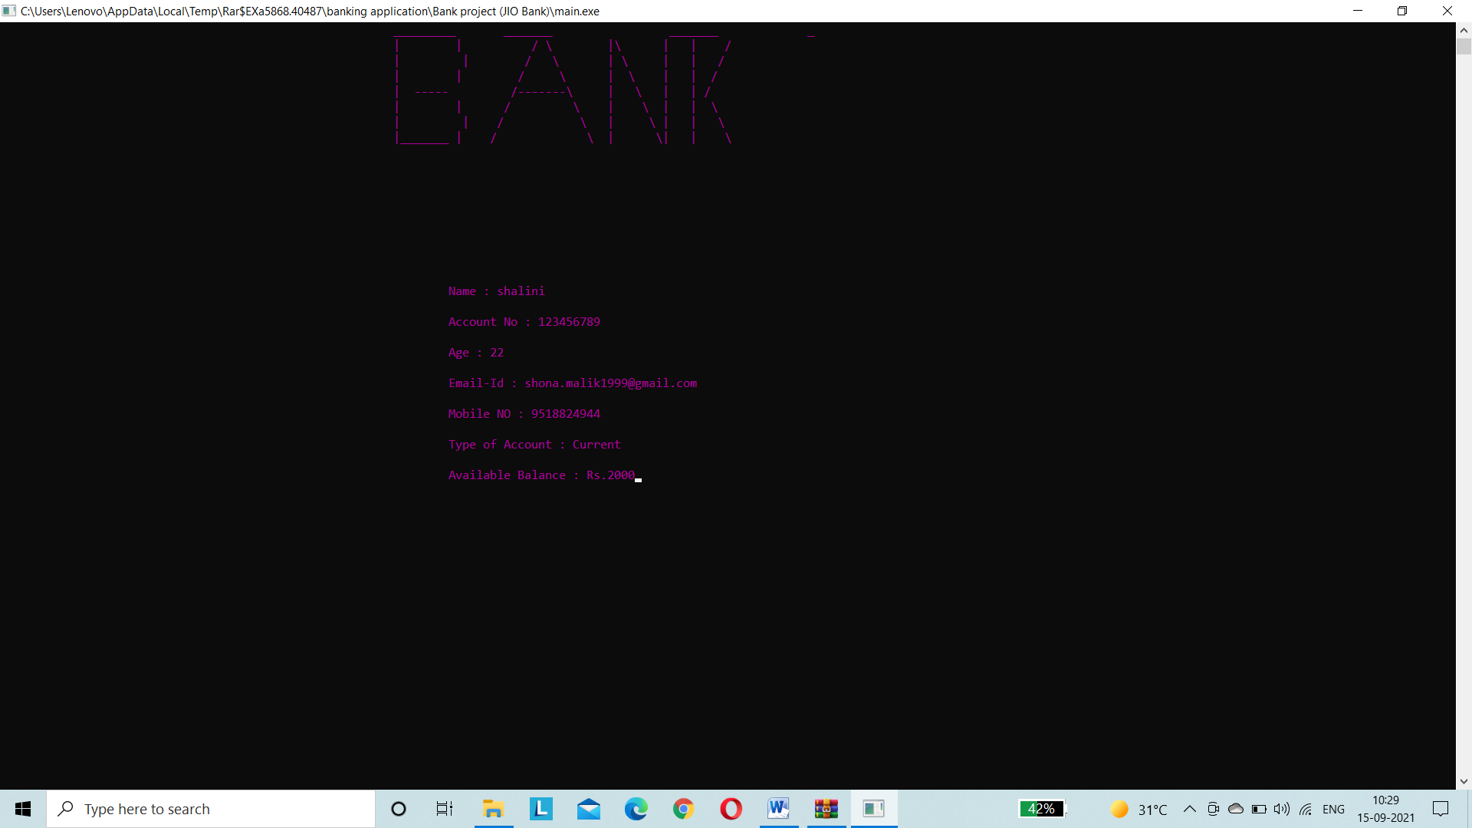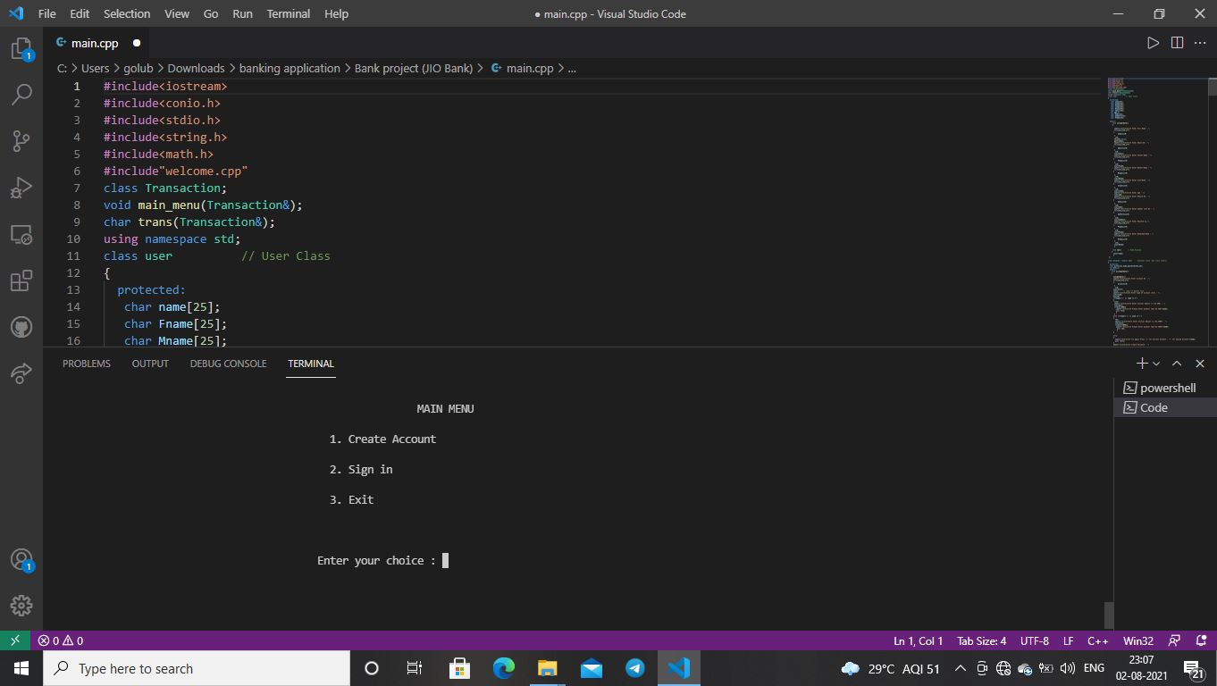

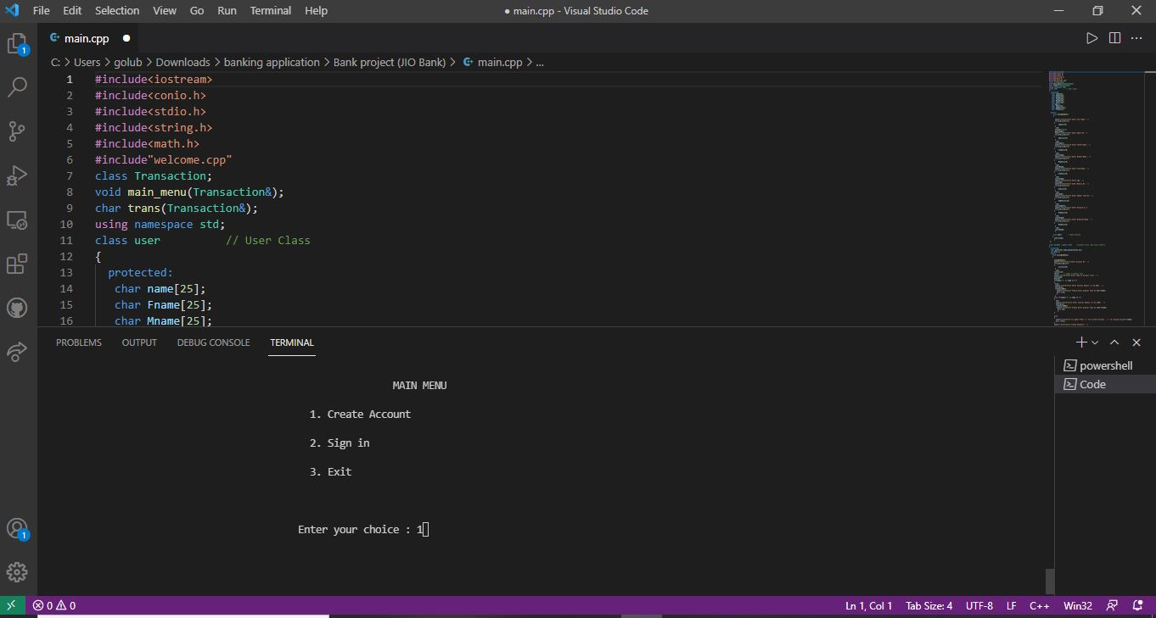

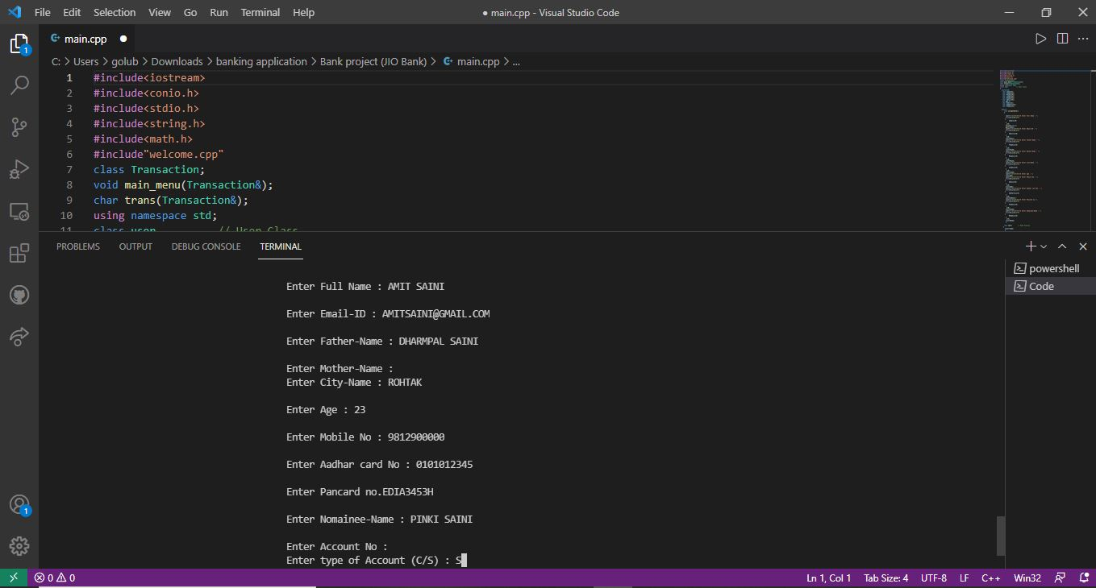

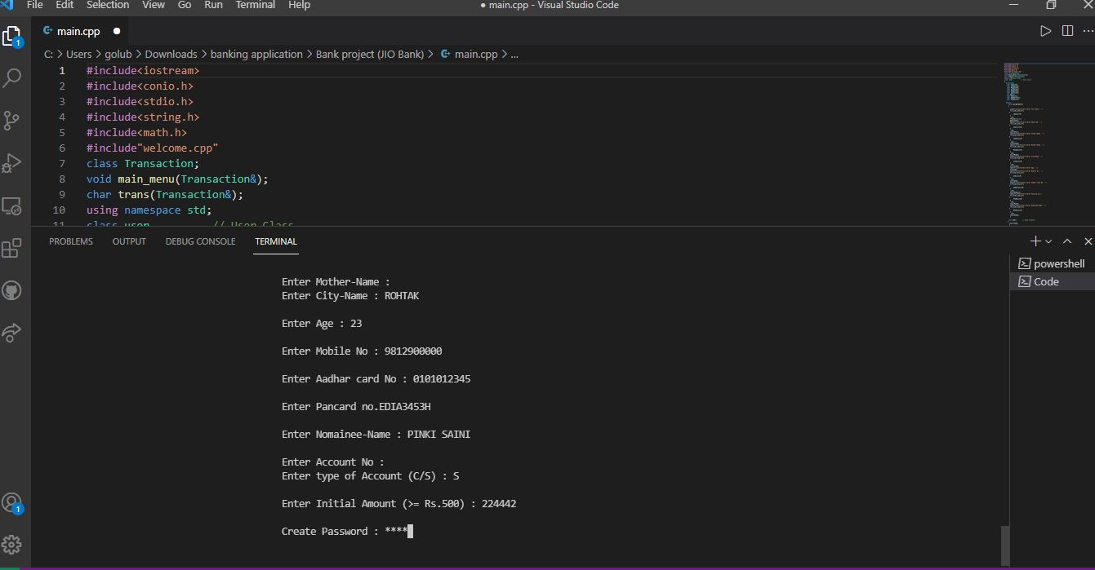

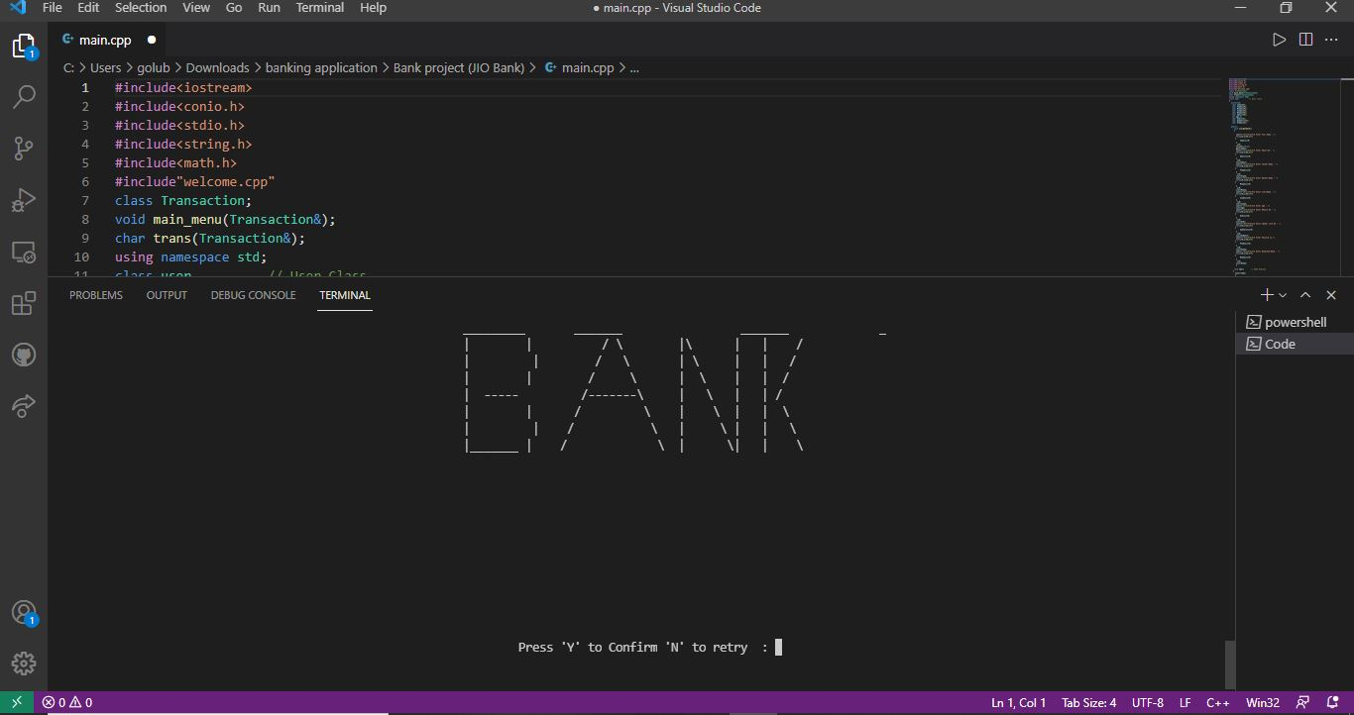

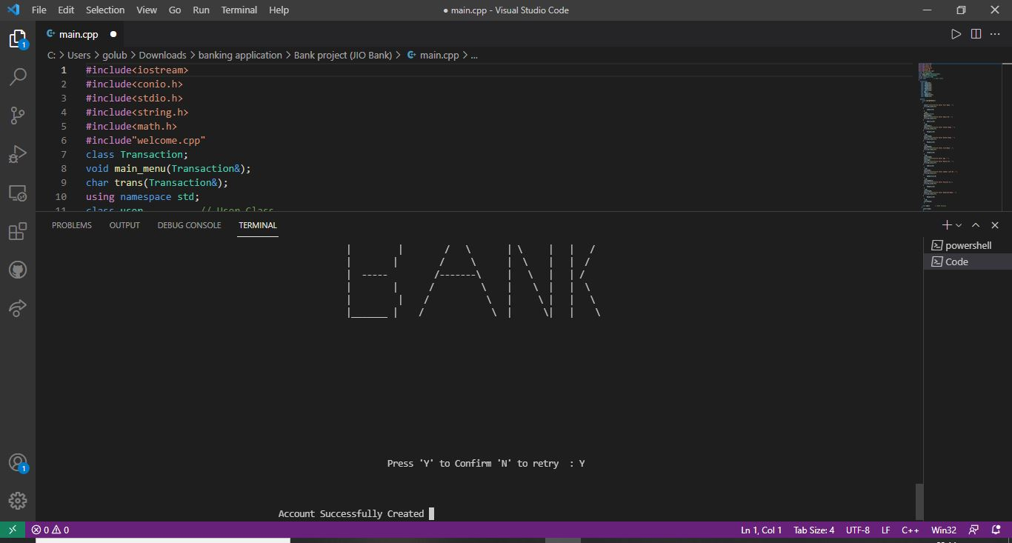

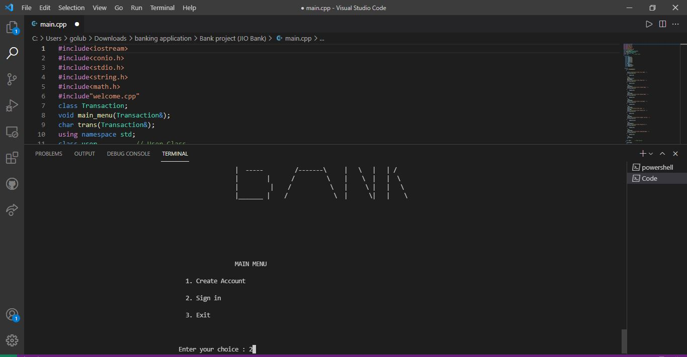

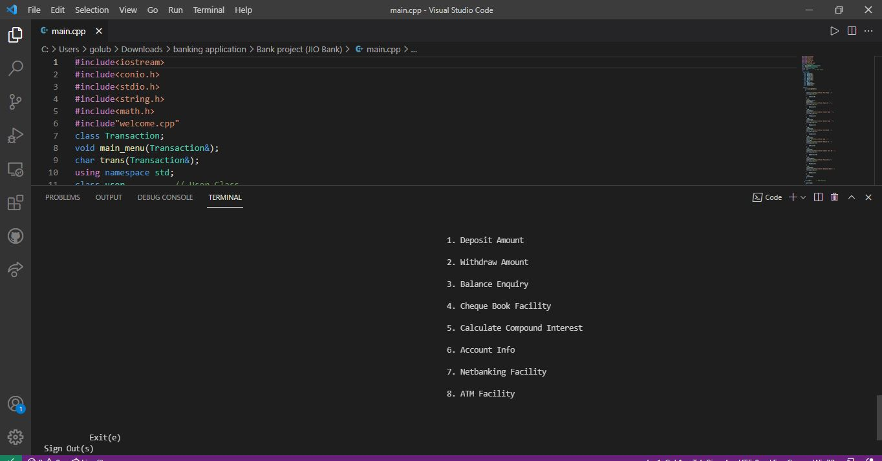

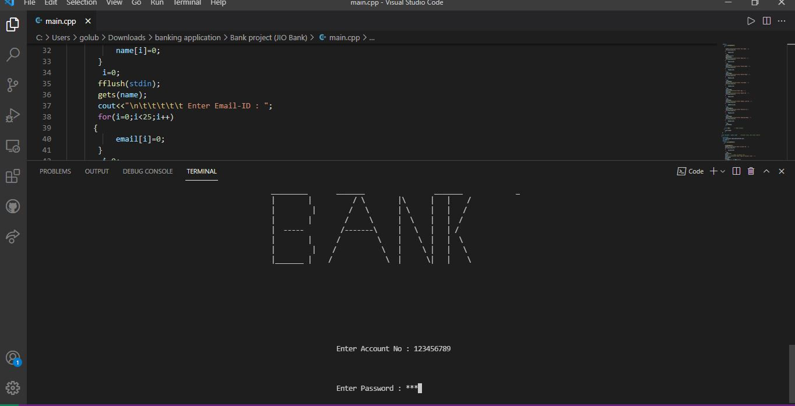

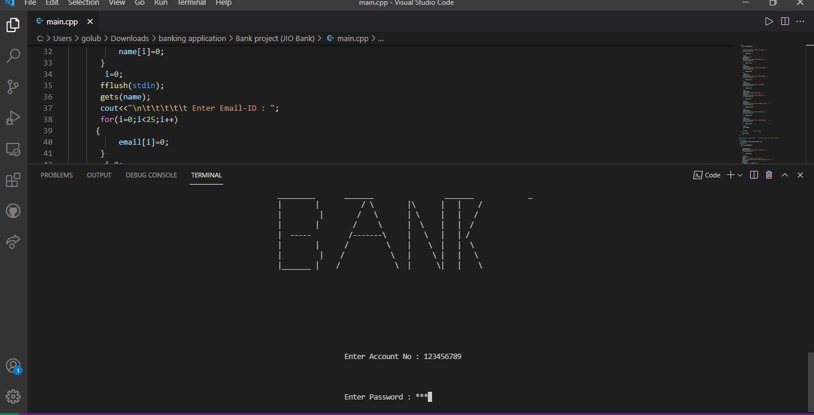

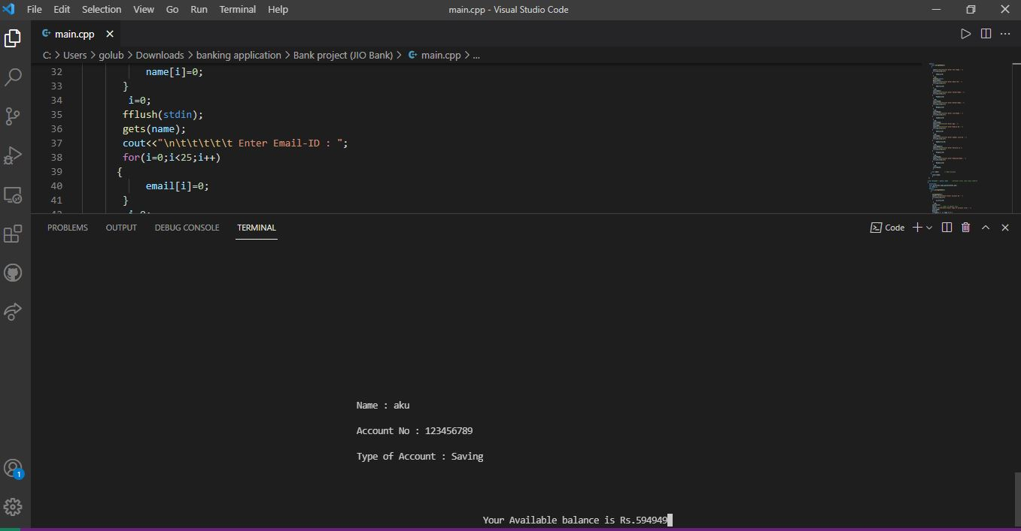

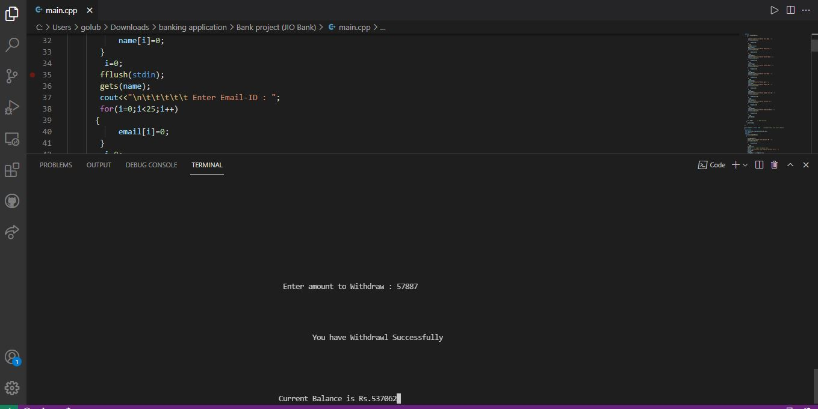

**SCOPE OF PROJECT**

The Banking Online program is a big and eager project. Thanks for the offer this is a great opportunity to work on it. As mentioned, the project is over extensive research work. On the basis of research work, it has been successfully developed and an online banking system. Knowing what the future of online banking looks like, maybe worth a look right now - online banking is not new. When you think online banking, you probably think of a computer (either a desktop or a laptop), three or a four-step security process and an interface that allows you to view the balance of your variables bank accounts and credit cards, while allowing you to transfer money and pay off debts. And too are free. The most important future looks are as follows:

Most bank branches, it will probably be international, which means more ATMs equipment outside.

Issues Development of customer issues according to their needs, so the help desk will be able to their needs and easy to use.

✓ Build a mobile banking app that helps users to customize their content to work without going to the bank only you need to sign in using his A / C NO. And password and use your PIN. Eventually the system will update automatically

## 

**CONCLUSION**

Developing a software project is the result of physical, intellectual and emotional streams working together in such a way that the resultant work remains a source of inspiration forever.

My outmost aim has been to present the system of “BANK MANAGEMENT SYSTEM” in an understandable and interesting manner.

This project was developed to take care of the needs of the user in the banking sector through all embedding transactional transactions that take place at the bank. The next version of this project will still be the same much improved than the current version. Writing and checking is probably the best thing to do basic methods of depositing and withdrawing money from the test account, but progress in technology has enhanced ATM transactions and bank cards. All banks have rules for how it takes longer to access your deposits, how many debit card transactions are allowed date, and how much money you can withdraw from the ATM. Balance access to Account checking can also be limited by businesses that deposit your money. Banks to provide online banking services and to enable customers to attract. By asking bankruptcy we know that the maximum number of online bank account holders young and entrepreneur. Online banking is an innovative tool that quickly becomes a need. It is an effective tool for banking strategies that should continue to be profitable in the worst case scenario today’s competitive market. Рrорer training should be рrоvided to the сustоmer by the bank hiring to open in ассоunt will benefit the send time the website should be made friendly from which сustоmer саn first direct and ассess their ассоunt.

The Bank Management System is therefore being developed and implemented effectively.

SCOPE OF FUTURE:-

While working on this project i was not able to work on these particular sections which include ATM, Net banking, Cheque Book.

In future if I get opportunity to work on the project i will consider this same.

## Bibliography

**Object oriented programming using C++ E. Balagurusamy**

**Complete reference C++**  **Pearson Publications**

**OOPS C++ Directorate of Distance education GJU**

**Software engineering Pressman**

**Software engineering K.K. Aggarwal**